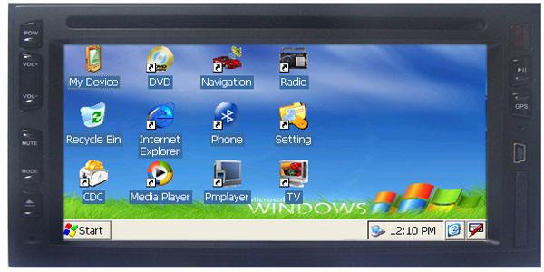

1.Windows CE Operation,3.Built in keyboard, can be connected with External Mouse
2.Wireless Internet connected with GPRS Modem
3.Built in Office file Viewer
4.Built in GPS
5.Bluetooth connectivity
6.In dash DVD Loader
7.AM/ FM digital tune, can save 120 stations
8.Back video input.
9.Digital TV with external DVBT Box(TV Box is Optional)
10.CDC Slot
11.USB&SD Slot
12.built-in 4 x 45W high power output amplifier
13.Original factory wiring harness and connector
14.Full function remote control
15.Real time display
16.Steering control smart match, Intelligent Steering control learning
17.Play music and video while NAVI or Surfing Internet

