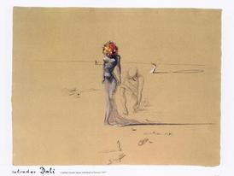

Desert Rose

I dream of rain
I dream of gardens in the desert sand
I wake in pain
I dream of love as time runs through my hand

I dream of fire
Those dreams are tied to a horse that will never tire
And in the flames
Her shadows play in the shape of a man's desire

This desert rose
Each of her veils, a secret promise
This desert flower
No sweet perfume ever tortured me more than this

And as she turns
This way she moves in the logic of all my dreams
This fire burns
I realise that nothing's as it seems

I dream of rain
I dream of gardens in the desert sand
I wake in pain
I dream of love as time runs through my hand

I dream of rain
I lift my gaze to empty skies above
I close my eyes, this rare perfume

Is the sweet intoxication of her love

I dream of rain
I dream of gardens in the desert sand
I wake in pain
I dream of love as time runs through my hand

Sweet desert rose
Each of her veils, a secret promise

This desert flower
No sweet perfume ever tortured me more than this

Sweet desert rose
This memory of Eden haunts us all
This desert flower, this rare perfume
Is the sweet intoxication of the fall

