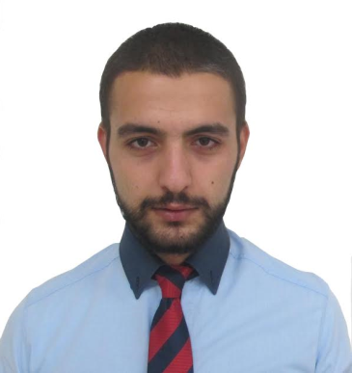
beqa ciskariSvili

02.09.1992w
q.Tbilisi, muxianis IIm/e korpusi 4, bina 110
b.tsiskarishvili@gmail.com
(+995) 591 00 72 78

ganaTleba
1998 – 2010 |  | q.Tbilisis, dimitri uznaZis saxelobis 22-e saSualo skola

kompiuteruli programebi
MS Office |  | kargad
Internet |  | kargad

ucxo enebi
rusuli  inglisuri |  | saSualod  saSualod

samxedro gamocdileba
2011-2012 |  | S.s.s. specialuri operaciebis centris, obieqtebis dacvis sammarTvelos, pirveli ganyofilebis, pirveli qveganyofilebis rigiTi – msroleli.

samuSao gamocdileba

01.04.11-30.10.12 internet-Jurnali “geosports.ge” - sportuli Jurnalisti

20.02.13-31.07.13 bakur sulakauris gamomcemloba – sawyobis TanamSromeli

09.10.13-05.06.14 hipermarketi “karfuri” – mimRebi departamenti – kontroliori

06.06.13-06.10.15 hipermarketi “karfuri” – mimRebi departamentis supervaizeri

07.10.15-dRemde hipermarketi “karfuri” mimRebi da sawyobis departamentis asistent menejeri

