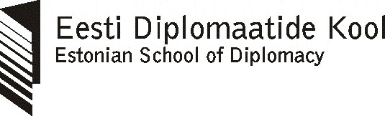

2007/2008 ESD scholarship program
for young Georgian diplomats and civil servants

In the academic year 2007/2008 Estonian School of Diplomacy (ESD) together with the Estonian Ministry of Foreign Affairs is offering two scholarships for young Georgian diplomats and/or civil servants in the area of international relations/politics or European integration. The scholarship will cover all expenses related to participation in the ESD nine-month (40 CP) training course International Relations and European Integration in Tallinn (September 2007 – May 2008).

Training course

The ESD offers a 40 CP (60 ECTS) training course “International Relations and European Integration” starting in September 2007 and finishing in May 2008. Successful graduates receive the ESD Diploma together with the Academic Record. Credit points earned can be transferred to other universities in order to receive the MA degree.

The training course consists of three modules:

- International Relations
- European Studies
- Diplomatic Studies

The course is taught in English.
The international study group consists of 20-25 students.
Lecturers come from Estonia, other EU countries and the USA.
Detailed curriculum is available at the ESD web site (http://www.edk.edu.ee).

Scholarship

Scholarship covers all expenses in Estonia related to participation in the training course:

- Tuition fee
- Accommodation
- Monthly allowance (4,000 EEK / 250 EUR)
- Health insurance

Scholarship does NOT cover the costs of air travel to and from Estonia.

Eligibility

The person applying for the scholarship:

- holds Georgian citizenship,
- is not older than 35 years (when applying),
- is currently employed in the Georgian foreign service or other civil service which deals with Georgia’s foreign relations and/or European integration, and has been employed there for at least one year,
- has good command of English language (speaking, reading, writing and listening skills are required),
- is highly motivated to learn about international relations and related disciplines,
- is co-operative and ready for multinational team work.

Application documents:

The applicant should present:

- ESD application form (downloadable from ESD web site),
- CV in English
- Copies of the higher education diploma together with the (unofficial) English translation,
- 1 document photo,
- Essay in English (2-3 pages) written on one of the three topics listed below.

Essay topics:

- Observing China’s economic growth
- The future of political Islam
- The choices of Ukraine

Application procedure

Application documents should be presented to the Georgian Ministry of Foreign Affairs. The Georgian MFA will forward documents to the ESD. The deadline for receipt of the applications is June 30, 2007. The ESD will announce the name of the winning candidate by July 7, 2007.

ESD address:
Estonian School of Diplomacy
2 Tõnismägi Street
10122 Tallinn
Estonia

Contact person: Mr Vahur Made, Deputy Director of ESD, vahur@edk.edu.ee, phone +372 631 7951, fax +372 631 7950.

