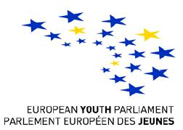
"The European Youth Parliament"
National Session
Tbilisi, Georgia
June 7-8

EYP Georgia Announces Selection of Participants for the
2nd National Session
will take place in
Tbilisi, Georgia
June 7-8

Requirements:
- Fluent English (written and verbal)
- Great Desire to experience unique EYP spirit
- Desire to learn more about EU
- Age 16-21

Applicants should send CV (Resume) or contact information to eyp.georgia@gmail.com
Deadline: 30th May

After Submission CV you will be informed to take part in the
2nd step of Selection
on 1st June,
Venue : Tbilisi State University

2nd step includes writing Essay on Given topic

EYP Georgia
National Session organising team
eyp.georgia@gmail.com

