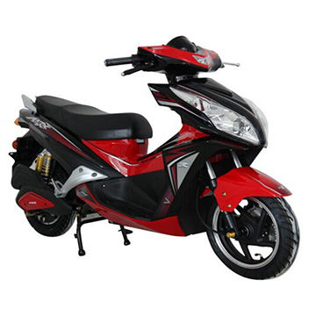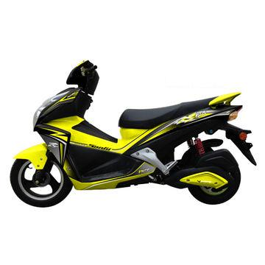

**1150$**

**Main specifications:**  
Bicycle size: 1890 X 680 X 1100mm  
Packaging size:   
Weight (W/O batteries): 72kg  
Weight (W/ batteries): 114kg  
Load capacity: 75kg  
Max speed: 40km/h  
Range per charge: >70km  
  
**Mechanical specifications:**  
Motor max RPM (no load): 515±10r/min  
Front and rear wheel center distance： 1330mm  
Rim (front/rear): F 12”X2.5”/R 12”X2.5”  
Wheel (front/rear): F 100/60-12 / R 100/60-12  
Brake (front/rear): F disc brake / R drum brake  
Brake levers (front/rear): F hydraulic pressure disc brake lever / R hand brake lever with cable   
  
**Electronic specifications:**  
Motor: 72V/ 1000W  
Batteries: 72V/ 20Ah  
Controller: 72V/ 33A  
Recharger: 72V/ 3A  
Over-current protection: 33A±1A  
Under-voltage protection: 63V±1V