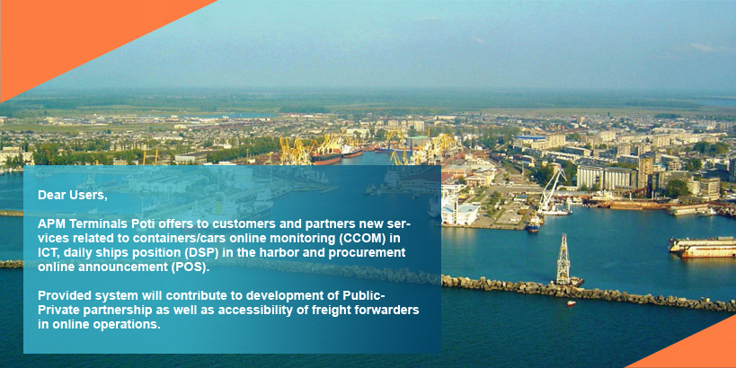

**CCOM Service**

[](http://www.apmterminalspoti.com/index.php#auth_box)

If you'd like to use this service please **[CONTACT US](http://www.apmterminalspoti.com/index.php" \l "contact)**

**DSP Service**

[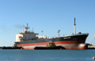](http://www.apmterminalspoti.com/index.php#auth_box)

If you'd like to use this service please **[CONTACT US](http://www.apmterminalspoti.com/index.php" \l "contact)**

Начало формы

Check Container Status

 

**PONU7454021 in Terminal..**  
Estimate Date of Stripping – 28.07.16

Конец формы

Начало формы

 Check Chassis  Check ICT # 

Конец формы

[Please click to get FastTrackService](http://www.apmterminalspoti.com/index.php#fast-track-service-success)