**Pricing Strategy**  
A. Georgia prices:   
1 ქილა 250 მლ საშუალო ფასი 3, 50 ლარია. შეკვრაში არის 24 ქილა---- 24x3, 50=84 ლარი  
B. Pricing Objectives  
Red Bull has a strict policy of keeping prices relatively similar and high compared to the rest  
of the beverage industry. Compared to can of Coca Cola, Red Bull is around 3-6 times more expensive. This is to always maintain the image of a premium, quality product.  
C. Pricing Strategy  
there are two separate sectors of pricing strategy based on the location of the point of sale:   
“ON” sector: Any place where product is consumed at location. Examples: nightclubs, restaurants, cafes Regional managers set this price at a constant level. Very little to no deviation of price. “OFF” sector: Any location where the product is consumed at a later time. Examples: grocery stores, gas stations. Pricing is still dictated by a regional manager, but more deviation and the possibility of sales exists. Red Bull uses penetration pricing. They are following this strategy for competition based pricing to achieve high customer loyalty after encouraging customers use the original and new products.  
D. Possible Disadvantages  
Due to the high price, the product may simply be too expensive for lower income  
demographics. Sampling Red Bull for the first time is much more expensive than other beverages thus possibly deterring the first purchase.  
E. Possible Advantages  
Customers often associate a high price with high quality. As a premium product with substantially high market share, Red Bull is able to charge such a high price without losing many customers.  
II. Positioning  
A. Price Communication  
Red Bull‘s overall value in the marketing mix is greatly affected by price.  
Due to a constant high price product, consumers believe that Red Bull is a premium product.  
B. Price Elasticity  
Red Bull has a high Price Elasticity of demand due to:  
1. Large number of substitutes (both within energy drinks and even more broad)  
2. Low degree of necessity (considered a luxury product)  
II. Product Life Cycle Stage  
Red Bull is currently in the Maturity stage. The company has begun to differentiate its product due to the large increase in substitutes. Much larger emphasis on brand loyalty. Growth figures are slowing down as the product ages (exception with 2011 where growth nearly tripled from the previous year)   
A. Distribution Channels  
to ensure quality Red Bull manufactures and packages all of its products by itself. The company does not license out or franchise their name all for quality control. Red Bull sells its product through the sectors mentioned above.  
B. Supplier-Retailer Relationships  
Red Bull has recently instituted a new program, called Perfect Partnership, for retailers that  
help grow the Red Bull brand.  Retailers will be rewarded based on the amount of Red Bull sold, the visibility of the product, the percentage of Red Bull in the store as compared to the rest of the energy drinks, and product placement.

**Marketing communications**

Red Bull’s targeted forms of IMC:   
A. Public Relations  
Red Bull is successful in their public relations field because they plan accordingly through:  
Generating extensive publicity across all mediums, such as: TV, radio, print, flyers, drinks, towels, stickers, cars, etc. Launching parties, activities, events, press releases, and commercials that clearly communicate the meaning of their product. Attracting spectators through fun and exciting projects. They make their product look interesting, intriguing, engaging to participate in and watch to the general public, as well as, the extreme. Also, Red Bull hits international frontiers. ( PR-ში)  
II. Social Media  
Red Bull invests in online platforms that will give them a better marketing ROI (მოგება საინვესტიციო კაპიტალიდან) in the long run. Instead of relying on audience traditional media properties, Red Bull is building their own audiences through business development and inbound marketing. Examples of how Red Bull shows content marketing and social media functions: Red Bull‘s homepage looks like an action sports news site. The company puts out professional-grade news articles, feature stories, and videos everyday which channels them to social marketing networks like Facebook and Twitter.  
III. Advertising  
Red Bull mainly markets through creative advertising, targeted sponsorships and events, and  
sampling to consumers, in order to receive their product.   
Media Advertising:   
Red Bull uses media channels, such as: cinema, TV, radio, press, and the most important,  
the Internet. Their focused advertisements are towards young people. Sports and Events Sponsoring: Company‘s concentration is on supporting the image, credibility, and visibility of their product. They do this by sponsoring extreme athletes and events, as well as, with logos and  
stickers.  
Sampling:   
Sampling the drink is a major purpose of Red Bull because Red Bull is all about being in  
the right place and the right time

Media strategy

Magazines

* We should take advantage of fact that magazines have become a very specialized medium. There are many consumers’ magazines in India.
* Good color production is also advantage that creates strong images with is the purpose of Red Bull.
* Provides critical brand awareness as well as clear and precise demographic selectivity
* Provides geographic flexibility across many urban markets.

Internet

Online advertising is similar to print advertising in that it offers a visual message. It also has additional advantages; it can also use audio and video capabilities. Interactive media would be opportunity for Red Bull to reach younger of both genders, to reach consumers who have developed a preference for online communication. Initiating a campaign on Facebook is very important to create buzz marketing and reach brand awareness we are targeting.

Outdoor

* On buses which is efficient carrier reaching mass audience.
* Billboards in specific geographical area would allow us get a good reach and frequency. It’s a low cost and flexible alternative.

TV

Ad campaign on prime TV channel such as NDTV, Good times, MTV, channel V, VH1 and few more.

* TV communicates with sight, sound and motion, which is needed for Red Bull. It’s the only media that can reach 99% of homes at once.
* RB has budget to cover high costs of this media.
* TV allows demonstration of advantages of RB goods.

Radio

Ads on different FM stations, which has high listeners.

Cinema advertising

Cinema Advertising is an effective form of communication as it visually communicates to our audience. Even though cinema advertisements could be expensive, but it has the ability to enable viewers to watch the advertisements with minimized distraction. Cinema Advertisement would be the ideal form of marketing communication because chances of them visiting the cinemas and watching a movie would be of a higher chance as compared to television programmes.

Sales promotion

Sales Promotions are to encourage immediate purchases on the spot by allowing their customers to have benefits and temporarily change in perceived price or value. The aim for them is to have customers, wholesalers and retailers to purchase in bulk thus creating a bonus gift pack of “Buy 5 Get 1 Free” bundle. We would not only expect our wholesalers and retailers to stock up on the product, we would also like them to sell our product aggressively.

Event sponsorship

Event Sponsorship mainly is to avoid media clutter and gaining approval of local sporting and youth constituencies. Red bull organizes many events. Such as: Wings for life, F1 Grand Prixes, Rally, Red Bull cliff diving, music festival and extreme sport events. This increases consumer awareness about brand and stimulates them to buy Red Bull goods. In Georgia Red Bull is sponsor of Tbilisi Open Air, 4 GB festival and other activities.

**Brand equity**

Brand awareness

Red Bull is known as premium energy drink brand. So for those who drink Red Bull feels as if they are not just drinking an energy drink but they are drinking the highest quality of energy drink. Consumers might also feel inspired because of the different celebrities that represent the Red Bull brand. Red Bull is well-known for its participation and sponsorship with extreme sports and events which helps heighten brand awareness; therefore, establishing CBBE with its consumers and nonconsumers. “Customer-based brand equity occurs when the customer has a high level of awareness and familiarity with the brands and holds some strong, favorable, and unique brand associations in memory”. Brand awareness is one of the sources of brand equity that Red Bull has efficaciously (ნაყოფიერად) achieved for over two decades. Through repeated exposure, Red Bull has increased familiarity of the brand worldwide, which has helped set the tone for multiple sources of brand equity. “Anything that causes consumers to experience one of a brand’s element–its name, symbol, logo, character, packing, or slogan, including advertising and promotion, sponsorship and event marketing, publicity and public relations, and outdoor advertising–can increase familiarity and awareness of that brand element”. In Georgia they maintain brand quality by good marketing which greatly is based on Word of Mouth.

Brand recognition

Since Red Bull was first launched, a number of competitors have entered the market, including Monster, Rockstar, and Full Throttle. Despite a saturation of energy drink offerings, Red Bull has effectively crafted the capability for consumers to remember and recognize the Red Bull brand. When consumers are searching for an energy drink, previous exposure to the brand through various marketing efforts has greatly affected consumers’ ability to recall the brand. Throughout Red Bull’s history, the company has remained true to its original marketing strategy which includes “traditional television, print and radio advertising, event marketing in sports and entertainment, sampling and point-of-purchase promotion”. A large majority of the global population can recognize the brand’s original slogan, ‘Red Bull gives you wings which originates from ‘Red Bull verleiht Flüüügel’. Additionally, Red Bull’s untraditional use of cartoons in advertising has also been influential in brand recognition. Figure 2 and 3 are great examples of Red Bull’s traditional marketing strategies.



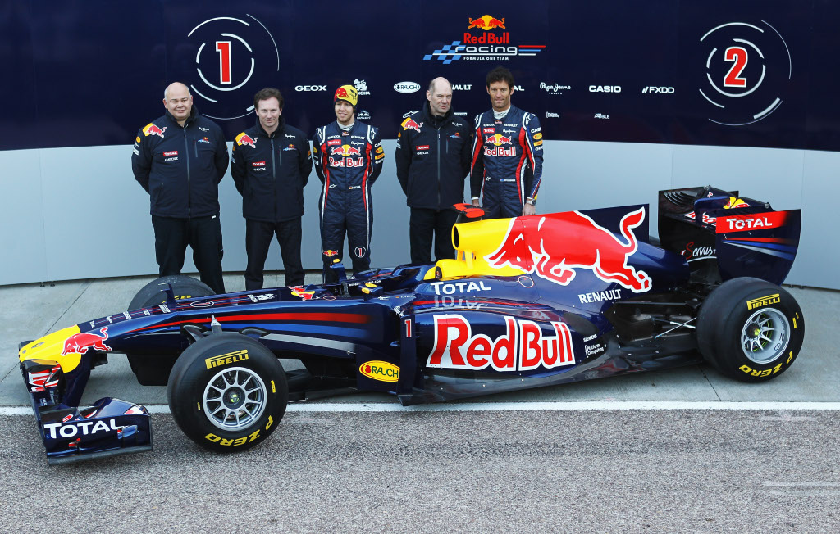

Brand image

The image a brand conveys can greatly affect positive and negative associations or perceptions of the brand. “Creating a positive brand image takes marketing programs that link strong, favorable, and unique associations to the brand in memory. Brand associations may be either brand attributes or benefits”. Red Bull is a respectable example of a company with a strong brand image that stands out among its competitors. Not only do consumers enjoy the product’s benefits, but they also associate with the brand’s positive attributes.

Consumer’s Perception that the brand is really good than they actually it is.

The aspect about gaining the brand equity is creating the perception about your brand in consumer’s mind that your brand is really good than actually it is. The same can be done by different ways by advertising or marketing more about end result in term of qualities and properties of the product to the user. In case of Red Bull Drink following tactics were used or applied. They came up with the slogan that “Red Bull gives you wings’. So people who really wanted boost their energy used to drink Red Bull. They also marketed or advertised on the energy enhancing ingredients of Red Bull like Caffeine, Taurine and Glucuronolactone. It also claimed the flowing properties. So consumers used to drink Red Bull to get some of these properties.

•Improve physical endurance.

•Stimulates metabolism and helps eliminates waste substances.

•Improves overall feeling of well-being.

•Improves reaction, speed and concentration.

•Increase mental alertness.

Next time they have changed the ingredients and flavor a bit. This they intended to communicate the product value as functional energy drink rather than just an energy drink. It was sweet in taste and carbonated as cola. As they were more concerned about the function of the drink they did not really care about the taste. The strong taste indicated to the customer that the drink was something more than mere refreshment. As direction printed on the cans drink served “well-chilled” most of the customer found the taste more pleasant when they drank it cold.

POP

* Bring energy
* Huge community around the brand
* Values around fun and excitement

POD

* Large event sponsoring and large advertisement budget
* Oriented to the extreme sport field
* Effective communication with Red Bull stratos jump

Customer based brand equity of Red Bull

The salience of Red Bull is clearly the energy drinks. Even if they make lots of sponsoring or if they have developed other ranges of products such as clothes and so on the Red Bull consumers associate the brand with energy drinks.

The imaginary of Red Bull is extreme sports because that is the image they want to be associated with by sponsoring lots of that kind of events. And guess what it works! In the mind of customers, Red Bull is associated with those events, for example the Red Bull jump in the Stratos really has caught the attention of all the people around the world.

The main performance claimed by Red Bull is the energy. The Red Bull drinks are full of caffeine, taurine and so on to allow their drinkers stay awaked all night long. This is their core characteristic.

The feelings that evoked this brand for the customers are fun, freedom and excitement with their large participation to extreme sports events. The fun feeling is conveyed by their ads or commercial for the consumers.

The affective reactions of the consumers thinking about Red Bull are the feeling of superiority because in term of spontaneous notoriety they are top mind, their communication is the best one among the three brands and also because Red Bull helps you to surpass yourself with the promotion of extreme experiences.

Finally the resonance of Red Bull is composed by loyalty, attachment and engagement. As we said in a previous article Red Bull has a strong brand community and people are really fan of this brand.

**Strengths and weaknesses (SWOT analysis)**

Strengths

Market leadership- Within the energy drinks market Red Bull is the industry leader throughout the world

Marketing Efforts- a lot of promotions and well-targeted campaigns and sponsorship e.g. formula 1 helps to expand Red bull brand and increase consumer brand awareness

Cadbury Schweppes alliance- Red Bull has a distribution agreement with Cadbury Schweppes; this is positive for further international expansion of brand.

Strong, fresh and fashionable brand identity

Weaknesses

Lack of innovation- there are a lot of competitors in the market and they have their own USP which leaves Red Bull behind.

Reliant on small product base- The Company only markets one branded product, Red Bull Energy Drink (along with a sugar free variety).

Lack of patent- A major weakness is Red Bull’s lack of patent in the recipe. This allows competitors to copy their recipe and enter the market easily. Furthermore, competitors may then use this as a starting place to launch its own unique selling point

Marketing expense- Extensive marketing efforts are required for Red Bull to boost product sales. The energy drinks have high association with fashion and youth trends, and the company must project itself as in line with this in the face of giant rivals such as PepsiCo.

Opportunities

Extension of product line- An extension of product line will aid them in increasing the market share. By introducing a new product, Red bull can use their strong brand awareness in promoting its new product.

Price competition- In the energy drink sector, competitors will strive to maintain high level of quality, convenience, price and related factors so as to stay competitive and bring higher satisfaction for consumers. Therefore, Red Bull has to be conscious of its pricing strategy and product quality to ensure the satisfaction level of consumers, in which bringing about brand loyalty

Innovation

Geographical expansion- With sales derived from 100 countries, Red Bull has an extensive geographical reach. The company is building upon this by making inroads into developing markets such as India. Red Bull will initially be promoted in North, East and Central India, with a view of rolling out the product to further regions in the long-term.

Threats

Red Bull’s energy drink has been banned in France due to concerns over its high caffeine content. Experts fear that the drink could be potentially deadly when combined with alcohol or when drunk after strenuous exercise.

Competition

Numerous substitutes