950$ 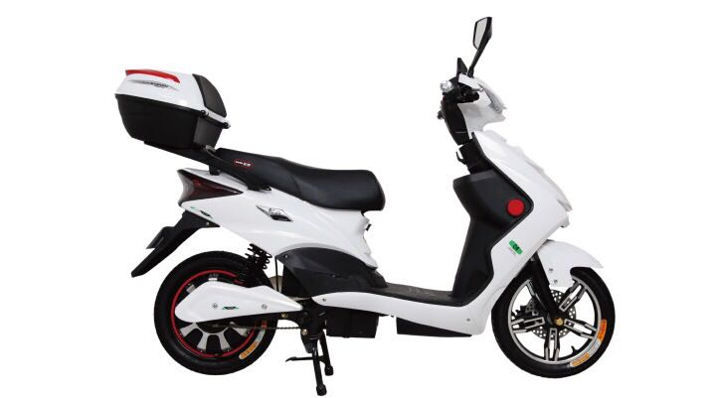

1. Main specifications:
2. Bicycle size: 1820X620X1060mm
3. Packaging size: 1860X550X1030mm
4. Weight (W/O batteries): 62.6kg
5. Weight (W/ batteries): 97.6kg
6. Load capacity: 75kg
7. Max speed: 40km/h
8. Range per charge: >60km
9. Mechanical specifications:
10. Motor max RPM (no load): 550±10r/min
11. Front and rear wheel center distance： 1270mm
12. Rim (front/rear): F 10”X2.5”/R 10”X2.5”
13. Wheel (front/rear): F 10”X3.0” / R 10”X3.0”
14. Brake (front/rear): F disc brake / R drum brake
15. Brake levers (front/rear): F hydraulic pressure disc brake lever/R hand brake lever with cable
16. Electronic specifications:
17. Motor: 60V/ 800W
18. Batteries: 60V/ 20Ah
19. Controller: 60V/ 33A
20. Recharger: 60V/ 3A
21. Over-current protection: 33A±1A
22. Under-voltage protection: 52V±1V